# COSC 3318: Database Management Systems

# (Assignment 4)

**Assigned on October 16, 2017. Typed and printed copy due at the start of class on October 27, 2017.**

1. Design a database for a bank, including information about customers and their accounts. Information about a customer includes their name, address, phone, and social security number. Accounts have numbers, types (e.g., savings, checking) and balances. Also record the relationship of customer(s) who own an account. Each customer can only have one account (30 points).
2. Draw the E/R diagram for this database. Be sure to indicate the key of each entity set.
3. Modify your diagram so that a customer can have a set of address (which includes street, city, and state) and a set of phones (area code and phone number). Be sure to include keys and arrows where appropriate.
4. Further modify your diagram so that customers can have a set of addresses, and at each address there is a set of phone numbers.
5. a) Design a genealogy database with one entity set: people. The information to record about persons includes their name, social security number. The people entity set has three different roles: mother, father and children (10 points).

b) Modify your diagram to include the following special types of people: Females, Males, and people who are parents. Use proper relationships to connect appropriate subclasses of people (10 points).

1. Draw E/R diagram for the following situation involving weak entity sets. In each case indicate keys for entity sets (20 points).
2. Entity sets courses and departments. A course is given by a unique department, but its only attribute is its number. Different departments can offer courses with the same number. Each department has a unique name.
3. Entity set Leagues, Teams and Players. League names are unique. No league has two teams with the same name. No team has two players with the same number. However, there can be players with the same number on different teams, and there can be teams with the same name in different leagues.
4. Covert the following E/R diagram with a weak entity set Bookings to a relational database schema.(10 points)

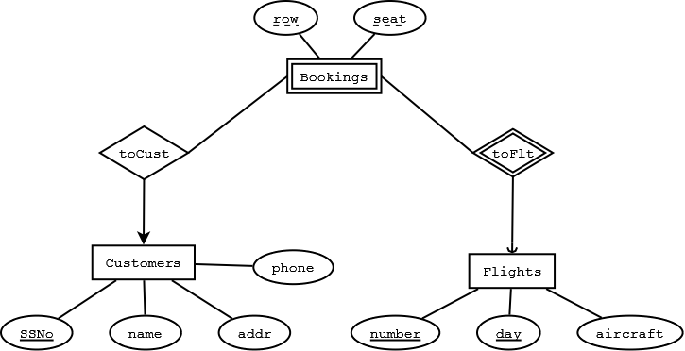

1. The Prescriptions-R-X chain of pharmacies has offered to give you a free lifetime supply of medicine if you design its database. Given the rising cost of health care, you agree. Here’s the information that you gather: (20 points)
   1. Patients are identified by an SSN, and their names, addresses, and ages must be recorded.
   2. Doctors are identified by an SSN. For each doctor, the name, specialty, and years of experience must be recorded.
   3. Each pharmaceutical company is identified by name and has a phone number.
   4. For each drug, the trade name and formula must be recorded. Each drug is sold by a given pharmaceutical company, and the trade name identifies a drug uniquely from among the products of that company. If a pharmaceutical company is deleted, you need not keep track of its products any longer.
   5. Each pharmacy has a name, address, and phone number.
   6. Every patient has a primary physician. Every doctor has at least one patient.
   7. Each pharmacy sells several drugs and has a price for each. A drug could be sold at several pharmacies, and the price could vary from one pharmacy to another.
   8. Doctors prescribe drugs for patients. A doctor could prescribe one or more drugs for several patients, and a patient could obtain prescriptions from several doctors. Each prescription has a date and a quantity associated with it. You can assume that, if a doctor prescribes the same drug for the same patient more than once, only the last such prescription needs to be stored.
   9. Pharmaceutical companies have long-term contracts with pharmacies. A pharmaceutical company can contract with several pharmacies, and a pharmacy can contract with several pharmaceutical companies. For each contract, you have to store a start date, an end date, and the text of the contract.
   10. Pharmacies appoint a supervisor for each contract. There must always be a supervisor for each contract, but the contract supervisor can change over the lifetime of the contract.
2. Draw an ER diagram that captures the preceding information. Identify any constraints not captured by the ER diagram.
3. How would your design change if each drug must be sold at a fixed price by all pharmacies?
4. How would your design change if the design requirements change as follows: If a doctor prescribes the same drug for the same patient more than once, several such prescriptions may have to be stored?